**Introduction**

We are attempting to leverage statistical and Machine Learning methods to predict patient survival. The idea is to create a model that helps the provider in better risk assessment. Which in turn can provide better intensive care facilities, provide personalized treatment, allocate resources for patients efficiently like getting the right doctors at the right time, timely change of medication or treatment, movement of patient to another facility etc.

Considering our team's work experience, past projects and interest in healthcare, we are participating in the datathon which focuses on patient survival prediction.

**Related Work**

**Apache System**

The APACHE system was first published long ago and provided predictions for patient mortality based upon data collected in the ICU. While the initial system was based on expert rules, later updates used data driven methods. In the kaggle competition we are provided all the fields that the apache system utilizes and therefore the models built are expected to perform better than the apache system.

Past models have been limited by technical and practical considerations, often using summary data from an entire day of a patient’s ICU stay which was manually documented by trained personnel [1]. There have also been models that leverage Multivariable logistic regression modelling to evaluate information from history, physical examination (for example, blood pressure), drug use, and quality of life questionnaires that independently contributed to the prediction of death [2].

It is worth noting that the models mostly used purely physiology, laboratory measurements, and minimal demographic variables available on admission, whereas the APACHE system utilized over 100 diagnostic categories, comorbid burden, and treatment. These additional features can often require manual collection which can complicate automatic application of the model.

**Other Methods**

Apart from the apache system other methods that have gained momentum include models based on Gradient Boosting , Lasso. There have also been models for specific conditions which instead of being generally applicable, find their use in certain specific situations like for patients with acute renal failure [3] or for [traumatically injured](https://journals.lww.com/jtrauma/Fulltext/2009/12000/Emergency_Department_Diversion_and_Trauma.48.aspx) patients [4]

**Project Topic and Proposed Solution**

**Project Topic :** Patient Survival Prediction using Machine Learning and Statistical Methods

**Dataset:** Primary Dataset to be used is intensive care unit data from hospitals in multiple geographic regions, hosted on Kaggle.

**Proposed Solution :** Based on the initial research we are planning to use an ensemble method by combining Machine learning and traditional statistical methods. The choice of methods and algorithms would be driven by the EDA and Feature engineering results, as well as our choice of handling missing data.

Our initial intuition suggests **a stacking approach.** Trying to model after how a doctor or a nurse would approach the problem. Considering that a doctor not only has a vast knowledge that was gained from medical school but an even greater knowledge based on experience which allows them to begin investigation from the generalized knowledge but then being able to map out and fit the current patient to any existing case that they had previously handled gives the doctors a great advantage. What this means for us is that we should **not just try generalizing the patterns in medical data but try and use neighborhood based approach** to be able to use the most similar case that we know about as a reference in predicting patient mortality.



**Research Question**

* **What features impact the survival of the patients?**
* **How does age affect patient survival? Do older patients have a higher chance of death?**
* **Which disease results in the most number of deaths?**
* **Patients with which disease have a high number of admissions and readmissions?**

**Data And Domain Description**

The data has been taken from Kaggle Competition where the challenge is to create a model that uses data from the first 24 hours of intensive care to predict patient survival. This dataset has data for more than 130,000 hospital Intensive Care Unit (ICU) visits from patients spanning one year time frame.

**Dataset Link:** <https://www.kaggle.com/c/widsdatathon2020/data>s

**Github Link:** <https://github.com/abhijeetdtu/Datathon>

**EDA**

The dataset has a total 186 variables including the dependent variable. The dependent variable is **hospital_death**.

We performed initial exploratory data analysis of the dataset in order to understand the data better by visualizing on Google Cloud Studio.

Following are some of the insights from the visualization.

We tried to follow a line of thought as to what type of data we have at hand, who are the patients, what are the demographics , what are the main conditions because of which patients are being admitted etc.

**What Data/Features do we have?**

|  |
| --- |
|  |

We began by examining what kind of data we have. For this we looked into the data dictionary. We see that **labs and vital readings** account for more than 50% of the data. i.e most of the columns in the dataset belong to these categories. Add to that **APACHE covariates** and we can account for almost 75% of the data. Apache Grouping and Prediction categories have very few columns compared to others.

**Who is getting admitted?**

|  |
| --- |
|  |

To understand whose data we actually have, we try to drill down along demographic lines.

We use **Ethnicity and Age** to drill into the data. From the Ethnicity Pie Chart, we see that most of the individuals in our dataset are **Caucasians** followed by African Americans.

|  |
| --- |
|  |

If We add another dimension - Age to the mix - we see an interesting pattern in the bar chart. We see that for African Americans in particular, the **proportion of patients declines with age.** We see that there are a number of young african american patients accounting for around 25-30% of total young patients but as we go upward in the chart to the older population we can see that the proportion drops to an average of around 10%.

**Where did they come from?**

|  |
| --- |
|  |

Next step is to explore how people ended up in the ICU. We can see that **Accident & Emergency** account for most of the ICU admissions which is 58.9% of the total admissions. ​Followed by Movement from the Operating room and then from the hospital wards.

**Why are patients getting admitted?**

|  |
| --- |
|  |

Having seen that most of the people end up in ICU because of an accident or emergency. We would like to see what kind of cases are usually seen in the ICU. For that we make a tree map of the diagnosis column. As it turns out most of the cases are Cardiovascular - heart attacks. We see that neurological cases , which might be from car crashes or other accidents , Respiratory and Sepsis cases also account for a large chunk of cases

**How Bad is it? : Hospital Deaths**

|  |
| --- |
|  |

Here we wanted to explore how often these ICU admissions are fatal. The pie Chart shows that the picture is not that grim with only 8.6% cases being fatal.

Value count of number of hospital deaths

|  |  |
| --- | --- |
| 0 | 83798 |
| 1 | 7915 |

There are 7915 not survived in the training set and 83798 patients survived from the analysis.

|  |
| --- |
|  |

If we further split the data based on different conditions, we see that most of the patients had diabetes. Comparing fatal cases to non fatal cases, we see an interesting pattern - there are different proportions for diseases in the two cases. Even though diabetes accounts for almost 80% of the non-fatal cases, it comprises only 60% for the fatal ones. Proportion for Hepatic Failures almost doubles from 5% to around 10% and for immuno​suppression they go from around 10% to 15%.

**Box Plots**

Using the graph, we can compare the range and distribution of various attributes for Survived patients(Hospital_death=0) and Not survived patients(Hospital_death=1).

**apache_4a_icu_death_prob**

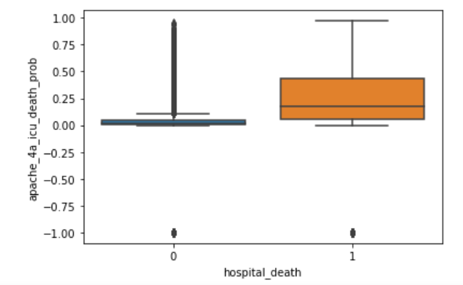

From the above box plot, we can see that the median of apache_4a_icu_death_prob for Survived and Not Survived patients differ which means that hospital death may be dependent on apache_4a_icu_death_prob

**Apache_4a_hospital_death_prob**

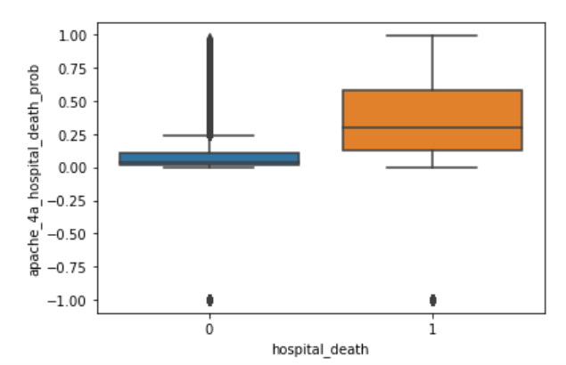

From the above box plot, we can see that the median of apache_4a_hospital_death_prob for Survived and Not Survived patients differ which means that hospital death may be dependent on apache_4a_hospital_death_prob

**Missing values:**

Around 160 variables have missing values out of which 74 variables have more than 50% of missing values.

Some of the variables with highest number of missing values:

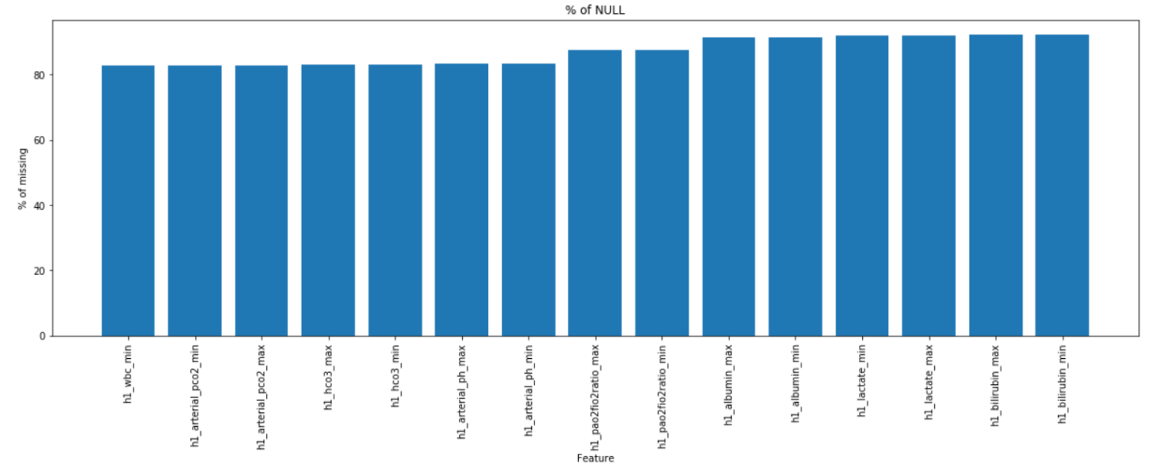

We would need to check if these values are missing at random or if there is a pattern associated with it.

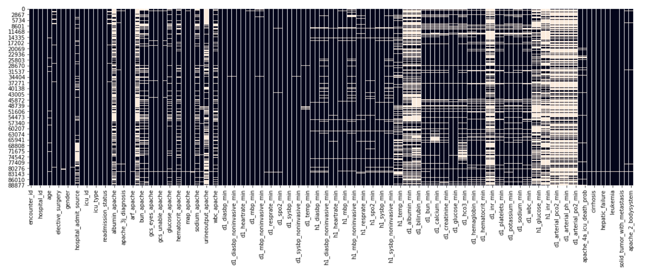

It was observed that most of the values which are missing are min and max of the same variable. Most of the missing values are across vitals, lab gas and lab reports. On further analysis it is seen that most of the missing values taken under the initial hour of admission (h1).

Most of the values are available for d1 (24 hours).

Number of missing values more than 50% in the case of initial hour(h1) is 44 while for 24 hrs(d1) is 21.

To check if the missing values are pertaining to some particular disease:

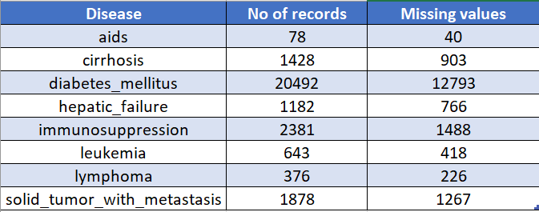

The missing values are spread across all the diseases and not biased over a disease

To check if there is any missing pattern across diseases, the variables were grouped based on the category as described in the data dictionary. It is observed that for all the diseases, the vitals and lab records were missing at random.

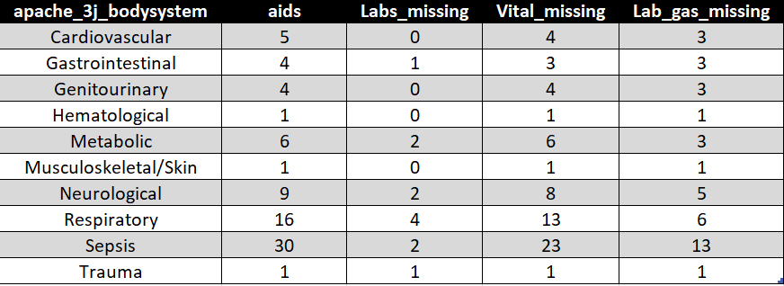

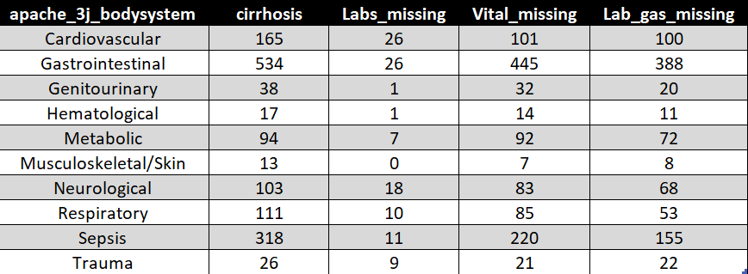

**Imputation:**

Since most of the missing values were falling under the initial hour observation(h1) and these values were explained by the values present in d1, the variables missing more than 50% in h1_variables were dropped.

Other variables such as albumin_apache, bilirubin_apache, Distribution of variables were checked before imputation:

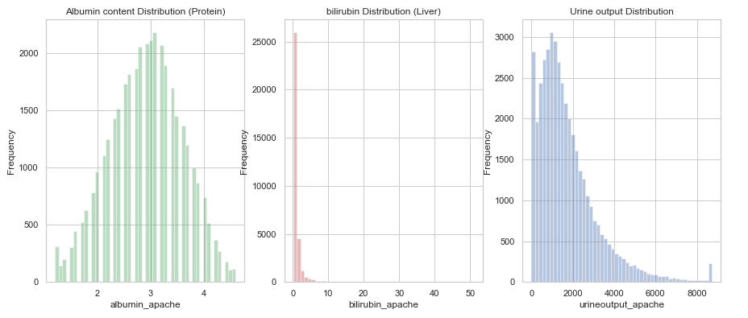

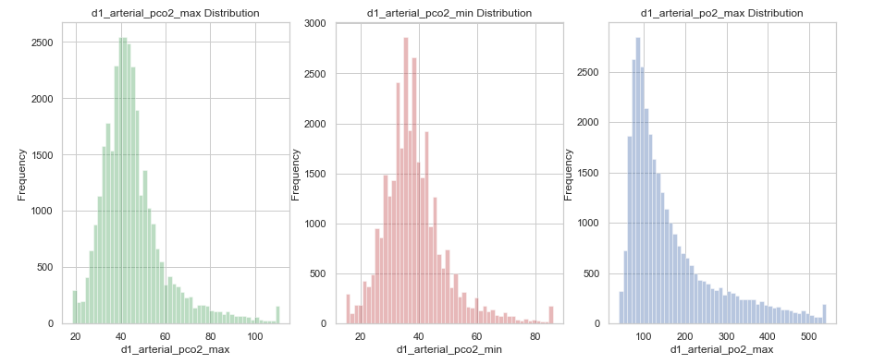

For the initial model Random forest was used for variable imputation.

Other imputation Approaches that were tried were

* **Clustering Imputation**
  + Idea was to cluster observations and then use cluster means to impute the observations

|  |
| --- |
| clusters = KMeans(n_clusters = 50).fit(ndf) |

* **Neighbor based Imputation**
  + Following similar line of thought as with clustering we tried to implement K-nn Implementation
  + Since Sklearn’s base implementation is all in memory therefore it needed 13.7 gb of space which was prohibitive - therefore we tried a number custom implementation using Dask (parallelization) , Numba (compilation) and KD Trees (approximation)

|  |
| --- |
| Dask Based |

|  |
| --- |
| Numba Based |

**Feature selection:**

Since there are many variables, Random forest was used to check the importance of features:

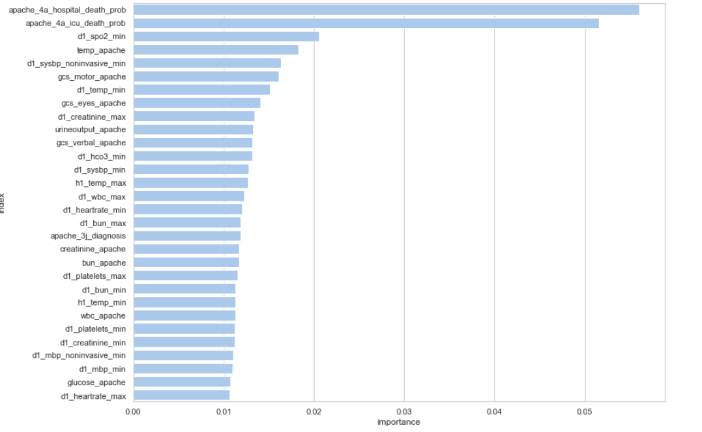

The most important features were apache_4a_hospital_death_prob and apache_4a_hospital_icu_prob.Since most of the feature importance was falling in the range of 1-2%, a random noise was introduced to see how its effect is different from the other variables

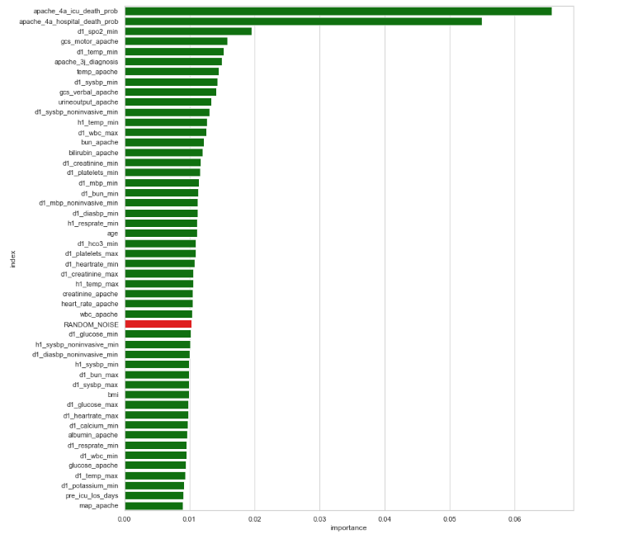

From the above chart,It was observed that most of the features have less importance as random noise introduced has more explanatory power than the other features following it.

To check if there is any variation in the feature importances if other techniques were used, ANOVA feature selection was used to compare the results:

|  |  |  |
| --- | --- | --- |
|  |  |  |

The results were quite similar.

Correlation heatmap

|  |
| --- |
|  |

### 

### 

### 

### 

### 

### **Recursive Feature Elimination**

We used RFE with the logistic regression algorithm to select the top 90 features.

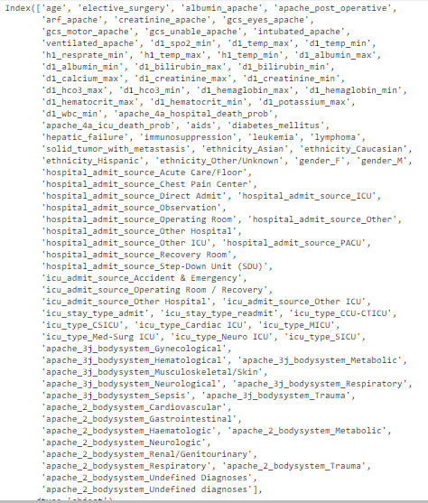

**PCA**

We also applied PCA to reduce dimensionality. After having imputed and Standard Scaling the numerical features we ran PCA only on the numerical features and the results showed that 100 features out of 157 could explain 100% of the variance.

|  |
| --- |
|  |

**Baseline Models:**

As a baseline model, the imputed data was split into test and train and Logistic Regression was applied to check the model performance.

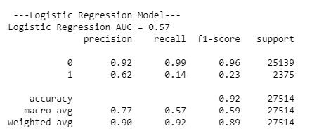

The baseline models AUC is just 0.57 which is quite less.

Since the number of records for hospital_deaths in the dataset is quite less as compared to surviving patients, there is an imbalance in the data. So different sampling techniques were used to see if it improves the model performance.

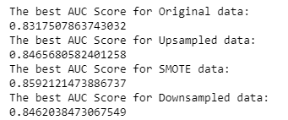

When different sampling techniques were used on the data, we can see drastic improvement in results.

**Yet Another Baseline**

We tried another baseline which

1. Imputed Based on Most Frequent Values
2. Converted Categorical Values to Dummy Variables
3. Dropped ID Columns like Hospital_Id , Encounter_Id
4. Used a Random Forest Classifier
5. This gave us Cross Validated AUC of 0.878 on average

|  |
| --- |
|  |

**Another Baseline Model - RF and Logistic Regression**

**Imputation** : Starting with handling missing values, we dropped columns that had more than 60% missing values, from 186 columns, 66 columns were dropped as they had more than 60% missing values, left with 120 columns.

Next, for the columns that had missing values, we imputed using average, max, backward filling and forward filling for different columns.

Since we were started by building a baseline model, we tried by imputing all the numerical columns with average value imputation, and other features with mode values.

Dummy Coding was used for Categorical variables.

We used Random Forest for feature importance, to use only the variables that were significant enough for the model.

**Model 1** :

For modelling we first split the data into train and test , then build the model using Random Forest to check the performance however, did not give a good accuracy and AUC.

|  |
| --- |
|  |

**Model 2:**

Also, trying different models, we build Logistic Regression with similar imputation of average, mean and mode.

We used Random Forest for Feature Engineering i.e importance, below are the results for accuracy and AUC of Logistic Regression.

|  |
| --- |
|  |

**Initial Kaggle Submission Model Summary**

### **Pipeline >**

* **Missing Values**
  + num_mean = **SimpleImputer**(strategy="mean")
  + cat_freq = **SimpleImputer**(strategy="most_frequent")
* **Add Apache Score column** - getAPACHEScore
* **Feature Transformations**
  + rs = **RobustScaler**()
    - Robust Scaler scales features using statistics that are robust to outliers.
  + pt = **PowerTransformer**()
    - Apply a power transform feature wise to make data more Gaussian-like
* **Feature Reduction**
  + We used Feature agglomeration/ clustering using correlation coefficient as the distance metric
  + fa = **FeatureAgglomeration**(n_clusters=None,affinity="precomputed",compute_full_tree=True, linkage="average" ,distance_threshold=1/corrcoefmin)
* **Categorical Columns**
  + ohe = **OneHotEncoder**(sparse=False , handle_unknown='ignore')
* **Modelling**
  + For the final model we used lightgbm
  + import lightgbm as lgb
  + The optimal parameters found using grid search were

params = {

'max_depth': 10,

'n_estimators ': 10,

'objective': 'binary',

'colsample_bytree': 0.8,

"class_weight":{0:1 , 1:20},

"base_score":0.2,

"n_jobs":-1,

"metric":"auc",

"reg_alpha":0.4,

"Reg_lambda":0.18,

}

The final Score we managed to get was 0.8978

**Issues Faced:**

* Since its healthcare data, **understanding most of the variables** needed spending some time going through the data dictionary.
* The data has many features which makes it **difficult to identify the important features.** Correlation among variables need to be considered while performing variable selection
* **Imbalance in the data** - we have a class imbalance where only 8% of the observations have the target class
* **Handling missing values**: Since there are multiple ways to handle missing data, the right way to handle it which goes in hand with the model selected is tricky.
* **Variable transformation:** Since there are multiple variables and each variable has problems of skewness and outliers associated with it, the right transformation technique would play a major role in model performance
* **Model execution and computational complexity**: Since the data is comparatively large with many features, few algorithms like SVM or grid search with Boosting algorithms would take a long time to execute

**Strategies used to encounter**

* Different Imputation and Feature selection techniques were tried by each member of the group and the results were compared to identify how its affects the model.
* Different models were tired to check its performance. Further hyperparameter tuning was performed manually to check if there is any improvement in model performance
* Data imbalance: Two approaches were used to handle this. One was upsampling of the data which showed significant improvement in results while the other method was to use Boosting and stacking algorithms which improves the performance by heavily penalizing the weak learners.

**Project Progress - Phase 3:**

**Model selection and hyperparameter tuning:**

**Deep learning using KerasClassifier**:

(Using different preprocessing techniques)

Correlated variables were removed and around 101 variables were left of the imputed data.The variables were scaled and finally, Deep Learning Model using Keras Classifier was implemented on the dataset.

Keras Sequential model was fitted:

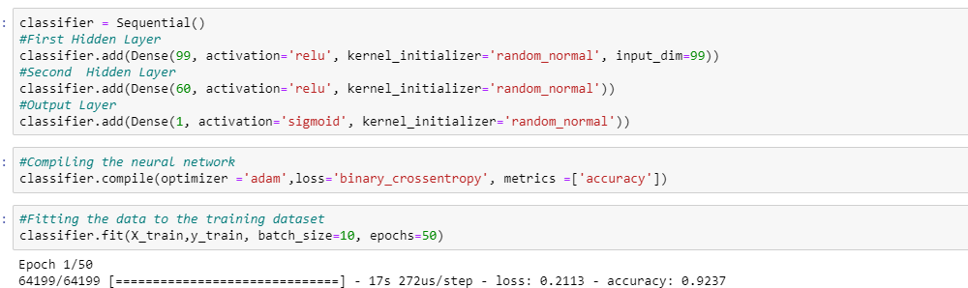

Accuracy = 98.7%

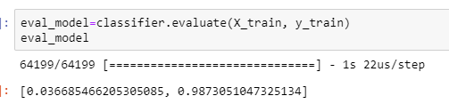

AUC = 78.44%

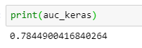

Different number of hidden layers were tested:

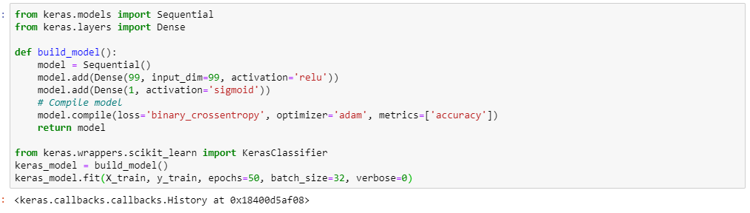

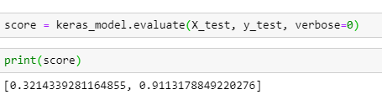

The accuracy obtained was 91% .

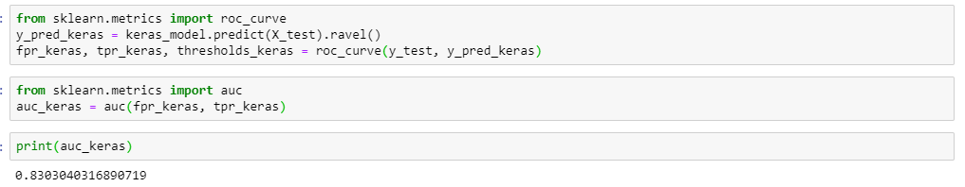AUC obtained was 83.03%

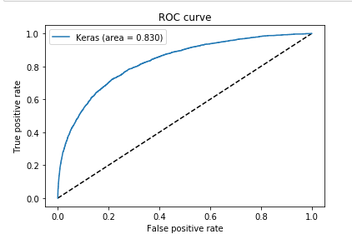

**Using GridSearchCV to find the best parameters for Keras Classifier**

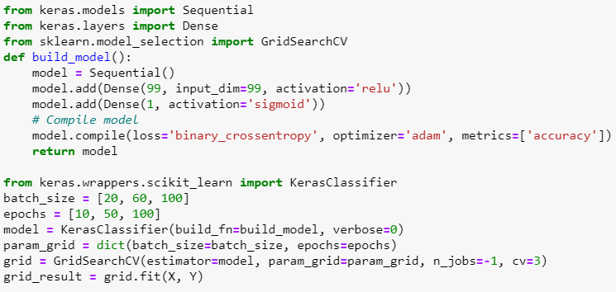

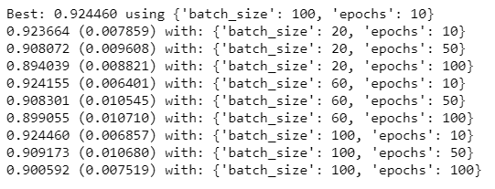

After getting the best parameters we got an Accuracy of 92.45 and AUC = 88.26

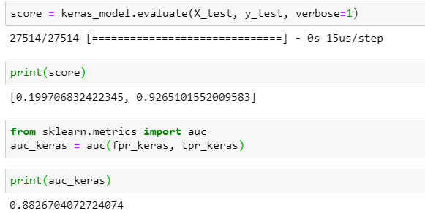

**Using Cloud:**

Hyperparameter tuning and genetic algorithms were tested

* Tuning of LGB model

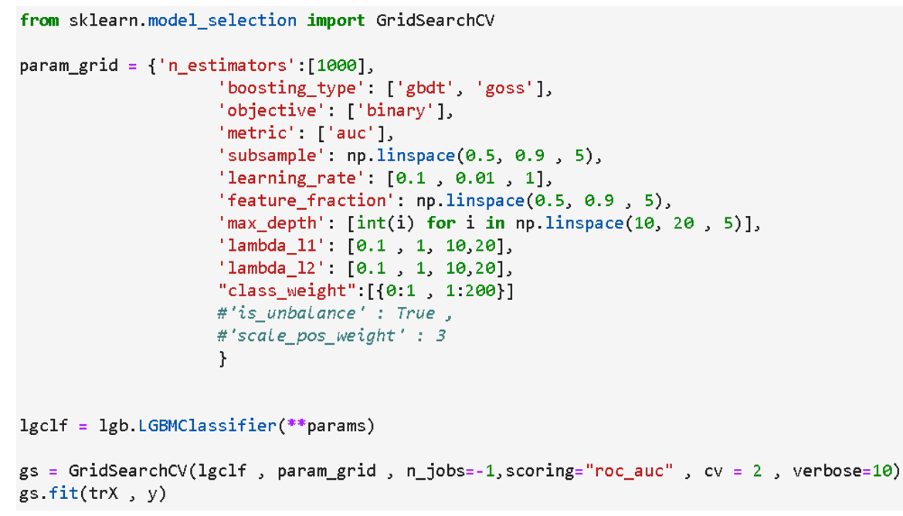

**Genetic Algorithms:**

* Also genetic algorithms were used for feature selection to see if they can find a feature subset that can improve the performance

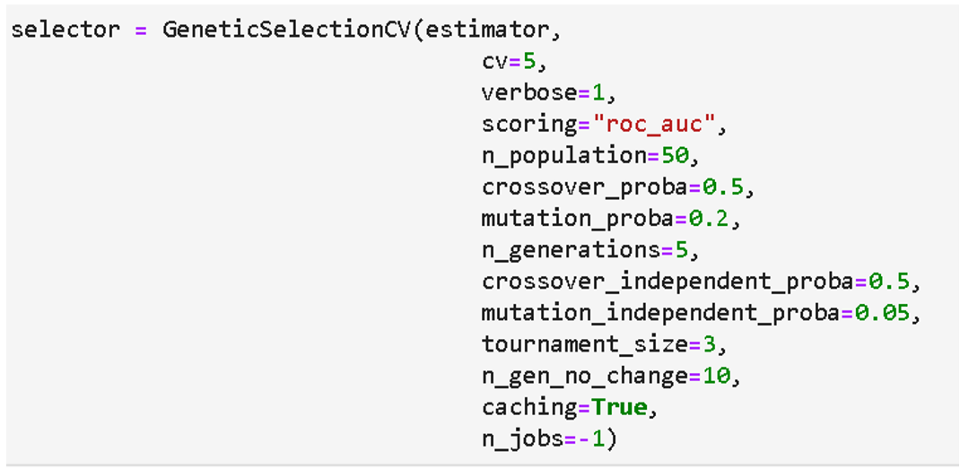

Even own implementation of genetic algorithm was tested

* Each individual in the population is a feature subset
* **Initially the population** consists of random individuals
  + 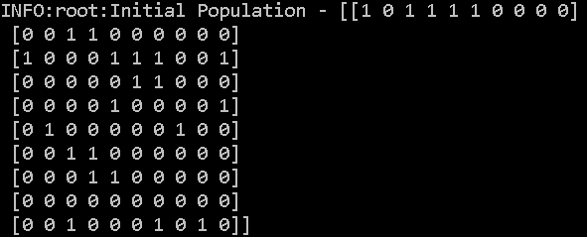
    - (results from a dummy problem with only 10 features with 5 informative features)
* Then these individuals are evaluated with a fitness score
* Most fit individuals are mutated and crossed over and the algorithm repeats for a number of epochs
* **Fitness function** looks like
  + 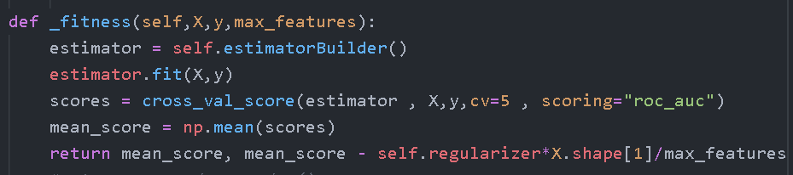
  + Basically a wrapper approach where any estimator can be used
* **Mutation function**
  + 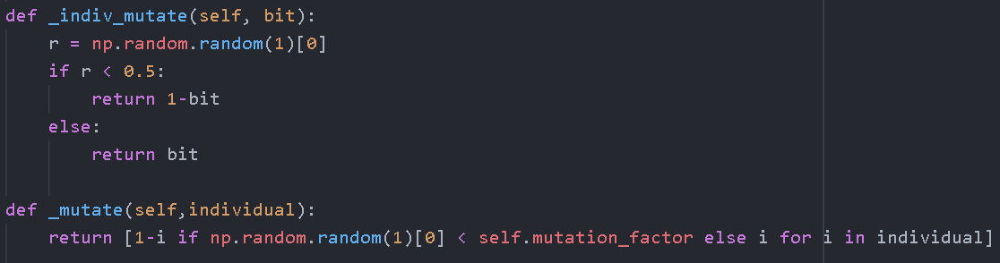
    - Essentially the features are randomly selected/deselected based on self.mutation_factor -[0,1]
* **Cross Over function**
  + 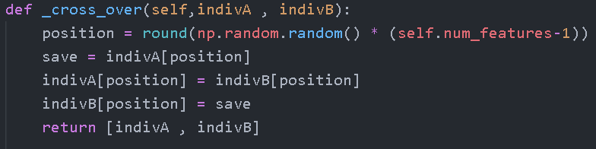
    - Basically takes two feature subsets and crosses them over at a randomly selected position
* Results on the dummy problems were good enough to warrant trial on the datathon dataset

Since there are a large number of computations needed for both hyperparameter tuning and for genetic algorithms,a cloud machine that is “powerful” enough with 16 vcores and 30gigs of RAM was created. GPUs were not available as apparently google cloud is extensively being utilized in coronavirus research.

Specs of the VM-



Models were queued to run…..

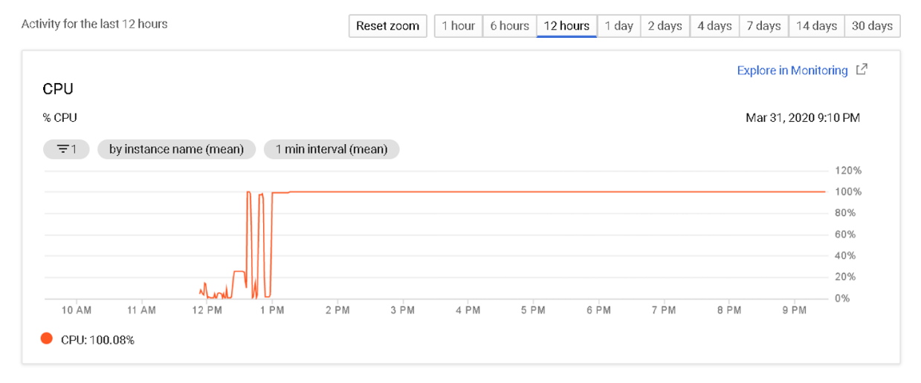

After 8 hours of waiting….

The LGB model had only evaluated 2296 possibilities out of the 12000

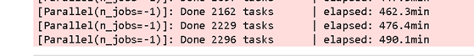

And the genetic algorithm had reached only 32nd generation with avg AUC of 0.882

Due to computational time this approach was abandoned

**Deep Learning and Stacking - Using Keras , Mlextend:**

* 1. 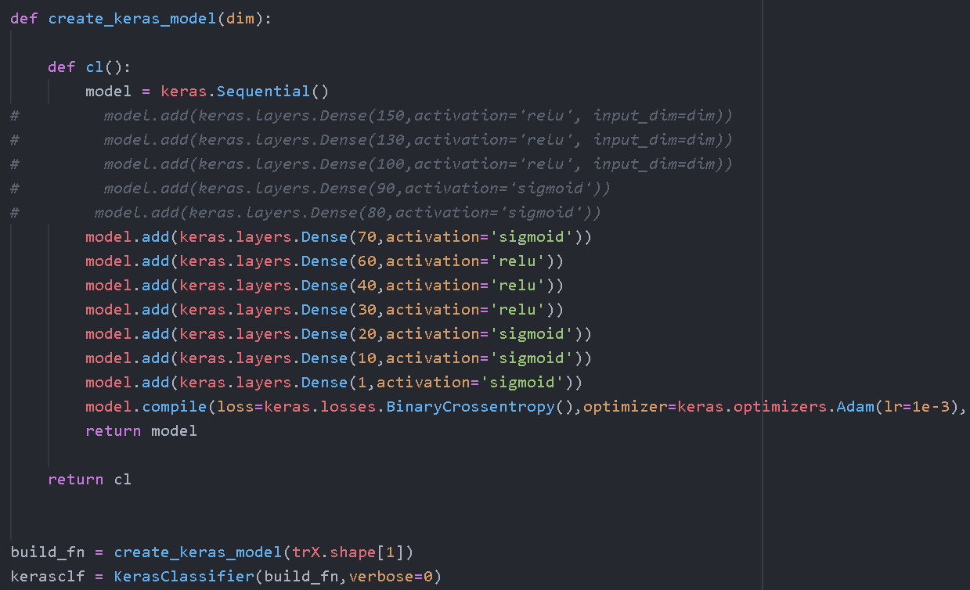
  2. Number of layers and activation units in each layer were varied
  3. Even tried stacking Sequential model with Light Gradient Boosting and SVM
     1. 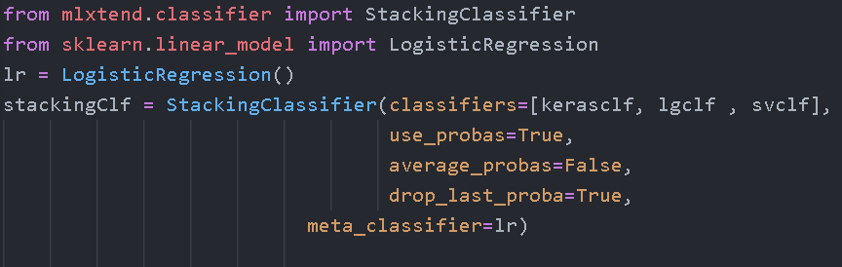

Few other approaches tried:

1. Using Different Categorical Encoding
   1. <https://contrib.scikit-learn.org/categorical-encoding/>
   2. Weight of Evidence encoding and Target Encoding were tried without any improvement in the AUC ROC score

2. Outlier Detection and Imputation

* 1. <https://pyod.readthedocs.io/en/latest/>
  2. K-NN based outlier detection approach was tried
     1. In this approach KNN outlier detection was employed and then 4 groups were created and each group was separately imputed so as not to directly impute with Mean or Most Frequent of the entire dataset, therefore minimizing data distortion
     2. 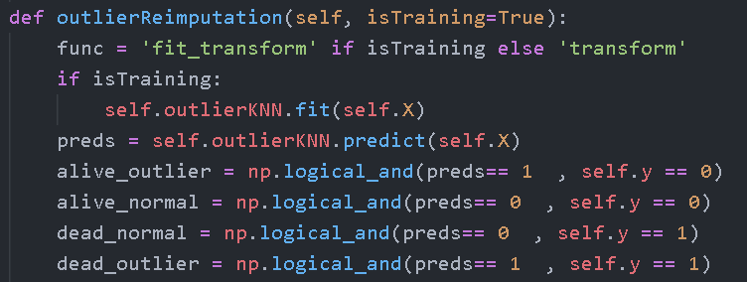

After having tested out most of the possibilities, without any improvement in score, this approach was abandoned.Scores were stuck near 0.89….

|  |  |  |
| --- | --- | --- |
|  |  |  |

The top Kaggle score in the leaderboard is 0.91497. With all the different approaches tested the results obtained by our team is 0.90150.

The best results obtained using boosting algorithms like XGBoost and LightGBM.

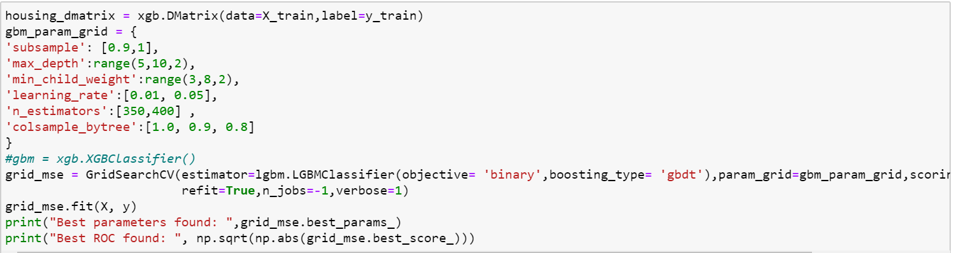

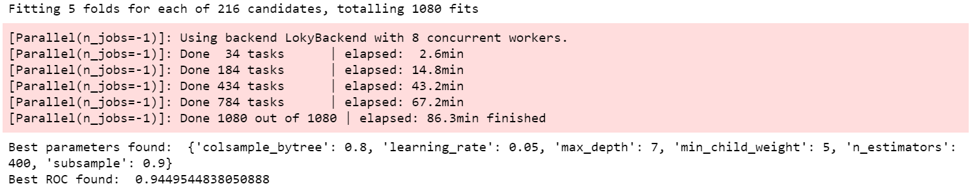

The accuracy obtained on Kaggle Leaderboard:

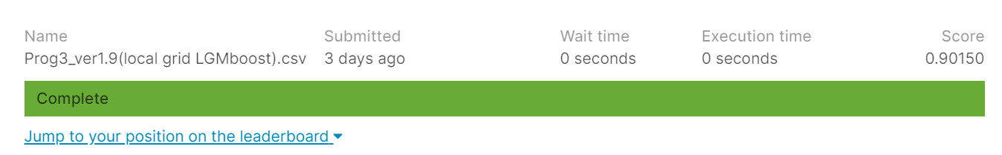

Link to the updated python file:

<https://github.com/abhijeetdtu/Datathon/tree/master/Datathon/EDA>

Filename: Final model tuning

**Key Takeaways**

1. **Feature Engineering is Key to everything**
2. Data issues

With datasets that have so many features as well as compounding data issues, it becomes imperative that we spend considerable efforts in getting the data in the right shape. Not only that but also have to be mindful of the fact that we need a bit of domain knowledge to be able to determine if the values that we are seeing are valid or not, in fact we could be seeing inconsistencies when looking at multiple columns together and resolving such issues, hard as it is, can significantly boost the signal in the data.

1. We don’t know what we don’t know

We were supposed to get a mentor for the project but didn’t and we feel that had we had a couple of sessions with an medical expert we could have identified issues that have clearly escaped our scrutiny.

1. Correlation doesn’t mean you drop features

One of the most important takeaway so far has been that correlation doesn’t mean that we drop the features. We have to be very careful when removing any data, especially entire columns. Columns that might be correlated with other columns, can reveal new information when combined with other columns. Therefore extra caution has to be taken before deciding to drop data.

1. Missing values are a pain

This particular dataset had so many columns that were almost sparse with data missing completely at random. In such cases it becomes challenging to identify when to impute and when to consider dropping. In some cases you might want to replace the column with a ‘isMissing’ column. Different strategies work on different columns and nothing seems to be grounded in theory but in empirically testing out different combinations.

1. Common Sense and Occam’s Razor

Even though complex transformations are what we usually think of, like power transformers or robust transforms and standard scalers and what not, but it's important to keep in mind Occam’s razor and look at the data pragmatically. Some very simple transformations can help boost the signal. One such transformation that worked for us was binning the ‘apache_4a_hospital_death_prob’ column. This column showed up as the most important feature in our analysis and ranged from 0 - 1 but simple binning of the column into 2 categories helped increase the score by 0.030 which is significant considering that we were stuck in a plateau of 5th decimal place.

1. **Hyper-parameter tuning**
2. Telescopic Search

We all know that Grid Search is exhaustive search, therefore it becomes crucial that we , as data scientists, know how to limit the search space. Exhaustive search of everything is not possible.

One technique that really helps is telescoping search where we try wildly different combinations in the first pass and then zoom in on the parameter values. This helps in initial elimination of vast search space.

1. Cloud is your new best friend

No matter how powerful your personal computer is, to be able to do Hyper parameter tuning satisfactorily and efficiently it’s wise to use cloud resources. Initial EDA, Feature engineering can be done locally but computationally expensive tuning workload should be taken to cloud.

We extensively used Google Datalab and Google Colab in parameter tuning. Even in cloud we had long running workloads that would take hours before we would get the results but that’s the best bet.

**3. Debug your model**

When hit with a plateau, instead of randomly tweaking the model, understand why it’s failing. Looking at confusion matrix and learning curves, they will at least enlighten you if the problem is with the model or with the data. Look at misclassified examples and understand why that is happening.

**Team Roles and Contributions**

|  |  |  |
| --- | --- | --- |
|  | **Team Member Name (800 id)** | **Responsible For** |
| **1** | **Abhijeet - 801155955** | **EDA using Google Cloud Data Studio,Python**  **Feature engineering -KNN , PCA, RandomForest,Clustering,Genetic Algorithm**  **Exploring Dask and Numba for faster computation**  **GridSearch and Hyperparameter Tuning for LightGBM**  **Github Documentation** |
| **2** | **Ridhi - 801151577** | **EDA - Python**  **Feature engineering - PCA, Random Forest**  **Model Selection - Logistic Regression, Deep learning - Keras Classifier,**  **Github Documentation** |
| **3** | **Vivek - 801151371** | **EDA-Python**  **Feature engineering - ANOVA and Random Forest**  **Model - Logistic Regression, XGBoost, Random Forest**  **Github Documentation** |
| **4** | **Mansi - 801136257** | **EDA using Google Cloud Data Studio, Python**  **Feature engineering - Recursive Feature Elimination, Model Selection - Random Forest , XGboost, Keras Classifier, GridSearchCV**  **Github Documentation** |

**References**

1. Johnson AEW, Mark RG. Real-time mortality prediction in the Intensive Care Unit. *AMIA Annu Symp Proc*. 2018;2017:994–1003. Published 2018 Apr 16.
2. Bouvy ML, Heerdink ER, Leufkens HGM*, et al*Predicting mortality in patients with heart failure: a pragmatic approach*Heart* 2003;**89:**605-609.
3. C E Douma, W K Redekop, J H van der Meulen, R W van Olden, J Haeck, D G Struijk and R T Krediet JASN January 1997, 8 (1) 111-117;
4. Cannon, Chad M., et al. "Utility of the shock index in predicting mortality in traumatically injured patients." *Journal of Trauma and Acute Care Surgery* 67.6 (2009): 1426-1430.
5. A clinical prediction model to identify patients at high risk of death in the emergency department :<https://www.ncbi.nlm.nih.gov/pmc/articles/PMC4477719/>
6. Emergency department triage prediction of clinical outcomes using machine learning models:<https://ccforum.biomedcentral.com/articles/10.1186/s13054-019-2351-7>